Supplementary Material

An ecological synthesis about the effects of floral plantings on crop pollination by bees

Cristina A. Kita^{1,2*}; Isabel Alves-dos-Santos¹; Michael Hrncir³; Sara D. Leonhardt⁴; Marco A. R. Mello¹

1. Department of Ecology, Institute of Biosciences, University of São Paulo, São Paulo, Brazil.
2. Graduate School in Ecology, Institute of Biosciences, University of São Paulo, São Paulo, Brazil.
3. Department of Physiology, Institute of Biosciences, University of São Paulo, São Paulo, Brazil.
4. Professur für Plant-Insect Interaction, School of Life Sciences, Technical University of Munich, Freising, Germany.

Systematic mapping

The effect of floral planting per crop

Almond
In almond crops located in California, U.S.A., floral plantings had different effects depending on the bee group. The visitation rate of honeybees did not differ between crops with and without floral plantings, which indicates that floral plantings neither competed with nor facilitated bee spillover to crops (neutral effect). However, the visitation rate of wild bees was higher in crops with floral plantings than without floral plantings, which indicates that floral plantings facilitated bee spillover to crops (exporter effect). The same was observed when comparing wild bee richness between crops. Nevertheless, an exporter effect was only identified when comparing bee visitation rate between crops with and without floral plantings (i.e., interior-interior study design). When comparing bee visitation rate between floral plantings and adjacent crops (edge-interior design), the visitation rate was higher in floral plantings than in crops (concentrator effect). The type of floral planting (i.e., hedgerow or flower strip) was not reported. The most abundant wild bee species collected was the cherry-leaf miner bee Andrena cerasifolii. Thus, in almond crops, the effect of floral plantings seems to depend on bee group and study design.

Apple
In apple crops located in Limburg, The Netherlands, richness and abundance of wild bees were higher in crops without than with floral plantings (interior-interior design), which indicates that floral plantings competed for wild bees with crops (concentrator effect). In this case, the type of floral planting used was hedgerows and the most abundant wild bee was the large earth bumblebee Bombus terrestris. However, in apple crops located in the Republic of Ireland, floral plantings had different effects depending on the bee group analyzed. The abundance of solitary bees and honeybees did not differ between floral plantings and crops (edge-interior design; neutral effect). However, the abundance of bumblebees was higher in crops than in floral plantings, which indicates that floral plantings facilitate bumblebee spillover to crops (exporter effect). In this case, flower strips were the type of floral planting, the most abundant solitary bee species was not reported, and the most abundant bumblebee was not identified to the species (Bombus sp.). Thus, for apple crops, the effects of floral plantings seem to depend on bee group, study site, study design, type of floral planting, and plant species composition of floral plantings.

Avocado
In avocado crops located in Casablanca Valley, Chile, the visitation rate of honeybees did not differ between crops with and without floral plantings (interior-interior design), which indicates that floral plantings neither compete with nor facilitate bee spillover to crops (neutral effect). In this case, the type of floral planting used were flower strips. However, in avocado crops located in Muranga, Kenya, the abundance of honeybees was higher in crops without than with flower strips (interior-interior design), which indicates that flower strips compete for honeybees with crops (concentrator effect). The same concentrator effect was observed for wild bees in avocado crops located in Valparaíso, Chile. In this case, the authors compared wild bee abundance between floral plantings and crops (edge-interior design), and the most abundant wild bee species was not reported. Floral planting composition was different between the three studied sites. Thus, for avocado crops, the effect of floral plantings seems to depend on bee group, study site, and study design.

Blueberry
In blueberry crops located in Michigan and Oregon, U.S.A., abundance and richness of wild bees did not differ between crops with and without floral plantings (interior-interior design), which indicates that floral plantings do not compete with nor facilitate wild bee spillover to crops (neutral effect). In this case, the type of floral planting used were flower strips. The most abundant bee species varied between the four studies conducted in Michigan. The following species were identified: Lasioglossum leucozonium, Lasioglossum zonulum, Bombus impatiens, and Andrena vicina. In the two studies conducted in Oregon, the most abundant bee species was Lasioglossum zonulum.
When the composition of the flower strip changed, the abundance of wild bees was higher in crops with than without floral plantings, which indicates that floral plantings facilitate bee spillover to crops (exporter effect). In this case, the most abundant bee was not identified to the species (Bombus sp.). The abundance of honeybees did not differ between crops with and without floral plantings, which indicates that floral plantings do not compete with or facilitate honeybee spillover to crops (neutral effect).
Finally, in blueberry crops located in British Columbia, Canada, the abundance of honeybees did not differ between crops with and without floral plantings (neutral effect). However, for wild bees, abundance was higher in crops without floral plantings (concentrator effect). The most common bee species were honeybee Apis mellifera and mining bee Andrena hemileuca, respectively. In these cases, the authors compared the abundance of honeybees and wild bees between floral plantings and crops (edge-interior design). Thus, for blueberry crops, the effect of floral plantings seems to depend on bee group, study site, and study design.

Cherry
In cherry crops located in Michigan, U.S.A., abundance and richness of wild bees and bumble bees did not differ between crops with and without floral plantings (interior-interior design), which indicates that floral plantings do not compete with nor facilitate bee spillover to crops (neutral effect). In this case, the type of floral planting used was flower strip. We identified two studies conducted in cherry crops in Michigan. Despite the same crop type, crop region, and floral planting composition, the most abundant wild bee species in one study was the sweat bee Lasioglossum leucozonium, and in the other it was the mining bee Andrena miserabilis, which evidences the influence of environmental factors acting in synergy with the other factors. The most common bumblebee species was not reported. Thus, for cherry crops, the effects of floral plantings seem to depend not so strongly on bee group, but on environmental factors that differ between sites of the same region.

Courgette
In courgette crops located in Cornwall, Worcestershire, and Cambridgeshire, U.K., the abundance of honeybees and wild bees was lower in floral plantings than in crops (edge-interior design), which indicates that floral plantings facilitate bee spillover to crops (exporter effect). In this case, the most common bee species were Apis mellifera and Bombus terrestris, respectively. The abundance of solitary bees was higher in floral plantings than in crops, which indicates that floral plantings compete for bees with crops (concentrator effect). The most abundant solitary bee species was not reported. In this case, the type of floral planting used were flower strips, and floral planting composition was the same. Thus, for courgette crops, the effect of floral plantings seems to depend on bee group.

Field mustard
In field mustard crops located in California, U.S.A., the abundance of honeybees did not differ between crops with and without floral plantings (interior-interior design), which indicates that floral plantings do not compete with or facilitate bee spillover to crops (neutral effect). However, the abundance of wild bees was higher in crops than in floral plantings (exporter effect), which indicates that floral plantings facilitate bee spillover to crops. Thus, in field mustard crops, the effect of floral plantings seems to depend on bee group.

Mango
In mango crops located in the central region of Thailand, the abundance of bees was higher in crops than in floral plantings (exporter effect; edge-interior design). The authors did not classify bee groups but reported that the dwarf honeybee Apis florea was the most abundant species in crops. However, when authors analyzed bee richness instead of abundance, floral plantings do not seem to compete with or facilitate bee spillover to crops (neutral effect). In this case, the type of floral planting used were flower strips, and plant species composition was the same. Thus, for mango crops, the effect of floral plantings seems to depend on bee community structure assessed (abundance or richness).

Melon
In melon crops located in Settat, Morocco, the abundance of honeybees did not differ between crops with and without floral plantings (interior-interior design), which indicates that floral plantings do not compete with nor facilitate bee spillover to crops (neutral effect). However, wild bee abundance was higher in crops with floral plantings, which indicates that floral plantings facilitate bee spillover to crops (exporter effect). In this case, the most abundant wild bee species was the sweat bee Lasioglossum malachurum.
In melon crops located in Murcia, Spain, floral plantings with different plant species composition also had a neutral effect for honeybees. However, for wild bees, they had a concentrator instead of an exporter effect. In this case, the most abundant wild bee was not identified to the species (Lasioglossum sp.).
In melon crops located in La Poveda, Spain, floral plantings had a different plant species composition as in Settat, Morocco. In this case, the authors did not report the bee group nor the most abundant bee species. Interestingly, the study was conducted in two sequential years. In the first year, bee abundance was higher in crops with than without floral plantings, which indicates that floral plantings facilitate bee spillover to crops (exporter effect). However, in the second year, bee abundance did not differ between crops with and without floral plantings, which indicates that they do not compete with or facilitate bee spillover to crops (neutral effect). In all three sites, the type of floral planting used were flower strips. Thus, for melon crops, the effect of floral plantings seems to depend on bee group, study site (crop site), floral planting composition, and other environmental factors.

Oilseed rape
In oilseed rape crops located in Republic of Ireland, the abundance of honeybees, bumblebees, and solitary bees did not differ between floral plantings and crops (edge-interior design; neutral effect). In this case, the type of floral planting used were flower strips. The most common solitary bee species were not identified. The most common bee species was Apis mellifera and the most common bumblebee species was Bombus spp. Thus, the effect of floral plantings seems to depend on factors other than bee group.

Potato
In potato crops located in Minnesota, U.S.A., the abundance of bees was higher in crops without than with floral plantings (interior-interior design), which indicates that floral plantings compete for bees with crops (concentrator effect). In this case, the type of floral planting used were flower strips. The authors did not report the bee groups. The most abundant bees were not identified to the species (Bombus spp.). For potato crops, there was only one study. Thus, more information is needed to assess the factors that determine the effect of floral plantings on crop pollination.

Red clover
In red clover crops located in Skåne and Östergötland, Sweden, the richness of bumblebees varied between the two years of experiment (as in melon crops) in crops with and without floral plantings (interior-interior design). In the first year, the richness of bumblebees was higher in crops with than without floral plantings, which indicates that floral plantings facilitate bee spillover to crops (exporter effect). However, in the second year, with the same floral planting composition, bumblebee richness did not differ between crops with and without floral plantings, which indicates that floral plantings neither compete with nor facilitate bee spillover to crops (neutral effect). In this case, the type of floral planting used were flower strips, and the most abundant species was Bombus terrestris. Thus, for red clover crops, the effect of floral plantings seems to depend on environmental factors that change between years, but further information is needed.

Strawberry
In strawberry crops located in the cantons of Bern, Zurich, Solothurn, and Aargau, Switzerland, abundance of honeybees did not differ between floral plantings and crops (edge-interior design), which indicates that floral plantings neither compete with nor facilitate bee spillover to crops (neutral effect). However, the abundance of wild bees and bumble bees was higher in crops, which indicates that floral plantings facilitate bee spillover to crops (exporter effect). In this case, the type of floral planting used were flower strips, and their plant species composition was the same in all sites. The most abundant wild bee species was the mason bee Osmia bicornis and the most abundant bumblebee species was Bombus terrestris.
In strawberry crops located in Göttingen (Germany), Slagelse (Denmark), Frogn (South-Norway), and Valldal (Mid-Norway), the abundance of solitary bees in floral plantings was higher than in crops (edge-interior design), which indicates that floral plantings compete for bees with crops (concentrator effect). In this case, the type of floral planting used were hedgerows, but plant species composition was not reported. In addition, the most abundant bee species was the mining bee Andrena haemorrhoa. Thus, for strawberry crops, the effect of floral plantings seems to depend on bee group, and there seems to be also an influence of floral planting composition and type, but further information is needed.

Sunflower
In sunflower crops located in Burgos, Spain, in two years of experiment, the visitation rate of honeybees did not differ between crops with and without floral plantings (interior-interior design; neutral effect). The same was observed for wild bees in the first year. However, in the second year, the visitation rate of wild bees was higher in crops with than without floral plantings, which indicates that floral plantings facilitate bee spillover to crops (exporter effect). In these cases, the type of floral planting used were flower strips, and plant species composition did not change between years.
In sunflower crops located in Cuenca, Spain, with the same type of floral planting composition as in Burgos and the same study design (interior-interior design), there were also neutral and exporter effects. As in Burgos, in the first year, the effect of floral plantings was neutral for honeybees and wild bees. However, in the second year, floral plantings facilitated the spillover of honeybees and wild bees to crops (exporter effect), which did not occur for honeybees in Burgos in the second year.
In sunflower crops located in Castilla-La Mancha, also in Spain, with the same floral planting as in Burgos and Cuenca, the richness of wild bees in floral plantings was higher than in crops (edge-interior design), which indicates that the floral plantings compete for bees with crops (concentrator effect). We also identified a concentrator effect in California, U.S.A. Not only the richness but also the abundance of wild bees in crops with and without floral plantings (interior-interior) were higher in crops with than without floral planting, even with different floral planting composition of Castilla-La Mancha. The most abundant bee species in California was the leaf-cutter bee Megachile montivaga. For Burgos, Cuenca, and Castilla-La Mancha, the most abundant bee species were not reported. Thus, for sunflower crops, the effect of floral plantings seems to depend on bee group, study site, bee community structure assessed (visitation rate, abundance or richness), and other environmental factors that changed between years.

Tomato
In tomato crops located in California, U.S.A., the abundance of wild bees was higher in crops with than without floral plantings (interior-interior design; exporter effect). The same effect was observed for wild bee richness. For honeybee richness, no information was reported. In these cases, the type of floral planting used were hedgerows, and floral planting plant composition was the same for all bee groups. The most abundant wild bee species was not reported. Thus, for tomato crops, we need more information. For example, studies on the effect of floral planting composition, as well as studies conducted in different years.

Watermelon
In watermelon crops located in California, U.S.A., abundance and richness of wild bees did not differ between crops with and without floral plantings (interior-interior design), which indicates that floral plantings neither competed with or facilitated bee spillover to crops (neutral effect). In this case, the type of floral planting used were flower strips. The most common bee species was the leaf-cutter bee Megachile apicalis. As for tomato crops, more information is needed.

Bibliometric mapping

Countries
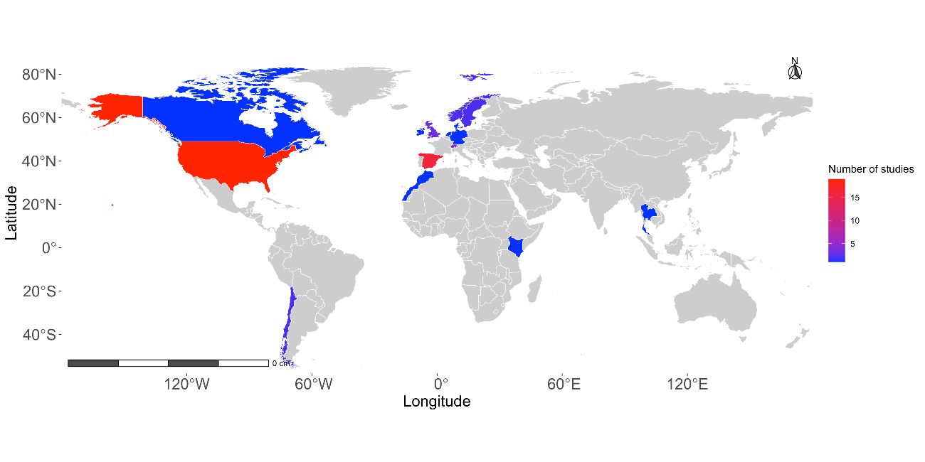 Fig. 1. Countries where the 26 articles retrieved in our systematic review of the effects of floral plantings on crop pollination by bees were conducted.

Journals
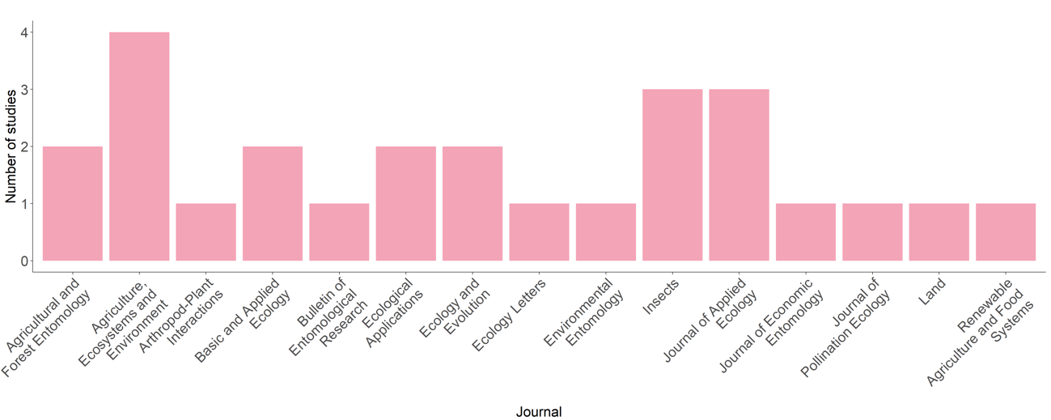
Fig. 2. Journals where the 26 articles retrieved in our systematic review of the effects of floral plantings on crop pollination by bees were published.

